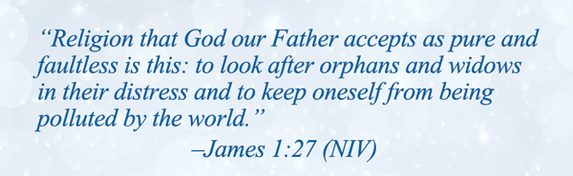

Our Church's role in caring for orphan children

God has called the church to span the gap between His heart for orphaned and at-risk youth and the huge problem that exists today. The church is God’s vehicle to reach the hurting and lost.

Today we embark on a mission to care for local children in need through prayer and sacrifice. As you listen to the sermon today, may the Holy Spirit stir in your heart the passion and direction of His plan for you.

Please consider these options
- Foster – Have A Home? Have A Heart? Change A Life! Learn about fostering and take the next step by scheduling an orientation or classes.
- Adopt - Every child needs a Forever Family! A place to call home for the holidays, a shoulder to cry on during the tough times, and a family to celebrate the good times in life!
- Advocate - Guardian ad Litem Volunteer Child Advocates represent the best interests of foster children in court making sure they don’t get lost in an overburdened legal system. Time Commitment = 10-15 hours a month, minimum 2 years
- Mentor –20 children are waiting for a mentor in PBC. Statistics show that most foster children are behind grade level. Time Commitment=1 hour a week, minimum 2 years
- Educate – Who Do You Know that We Should Know? Reach out to your friends to share the need. Help us reach families able to foster by hosting an info session at your home, office, or civic group.
- Wraparound – Join a special team of volunteers willing to share their time and treasure with a family who made the commitment to Foster a Child. Common needs are babysitters (cleared), meal preparers, midnight formula shoppers, and more.

Everyone. Can. Do. Something!

Learn how at: http://www.pbcunites.org/faith-based-advocacy.html

Our Church's role in caring for orphan children

God has called the church to span the gap between His heart for orphaned and at-risk youth and the huge problem that exists today. The church is God’s vehicle to reach the hurting and lost.

Today we embark on a mission to care for local children in need through prayer and sacrifice. As you listen to the sermon today, may the Holy Spirit stir in your heart the passion and direction of His plan for you.

Please consider these options
- Foster – Have A Home? Have A Heart? Change A Life! Learn about fostering and take the next step by scheduling an orientation or classes.
- Adopt - Every child needs a Forever Family! A place to call home for the holidays, a shoulder to cry on during the tough times, and a family to celebrate the good times in life!
- Advocate - Guardian ad Litem Volunteer Child Advocates represent the best interests of foster children in court making sure they don’t get lost in an overburdened legal system. Time Commitment = 10-15 hours a month, minimum 2 years
- Mentor –20 children are waiting for a mentor in PBC. Statistics show that most foster children are behind grade level. Time Commitment=1 hour a week, minimum 2 years
- Educate – Who Do You Know that We Should Know? Reach out to your friends to share the need. Help us reach families able to foster by hosting an info session at your home, office, or civic group.
- Wraparound – Join a special team of volunteers willing to share their time and treasure with a family who made the commitment to Foster a Child. Common needs are babysitters (cleared), meal preparers, midnight formula shoppers, and more.

Everyone. Can. Do. Something!

Learn how at: http://www.pbcunites.org/faith-based-advocacy.html

